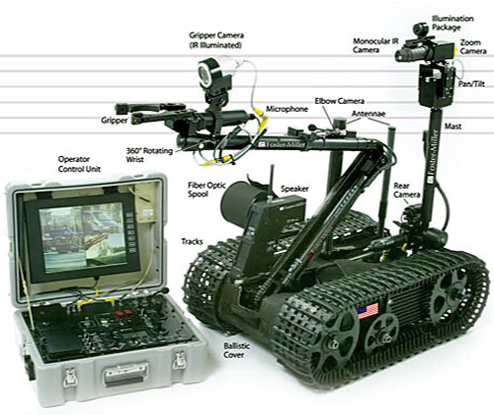
First Robotic Vehicle Assignment: Get Going
On program, type the name of the program, your names, what is connected to the ports (i.e., motors= B&C, sound sensor=port1, light sensor=Port 2)
Main program should have the story (algorithm) of what the robot is doing
Make sure you configure the icons with the correct ports.
To get credit, demonstrate robot and print out your program
Part 1: Go to line and stop, using time ( i.e. motors go for 3 seconds)
Part 2: Go to line and stop using rotations (i.e. motors turn for 4 rotations ).
EC: Talk while walking (connect sound icon to a parallel sequence beam)
EC: Smile while going (connect display icon to a parallel sequence beam, wait for time.

Part 3: Go to line, turn 180 degrees, stop- use steering control.

Part 4: Go to line, turn 180 degrees, repeat four times( place loop first, put motor icons into loop, select loop count for 4 )- Go around square, staying as close as possible to lines. Print this out and hand in.
8. Go a long distance- 10 feet or more- can you hit a 1 foot window? Does it drift?

