Challenge Part II: Navigate the maze using a color sensor and a series of switches in a loop( this is termed a polling algorithm) to read 'signs' indicating where to turn-for example
- If blue detected, turn right
- If green detected, turn left
- If red detected, stop
- If yellow detected-slow down
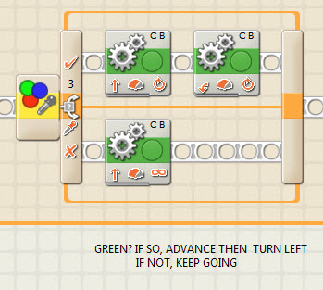
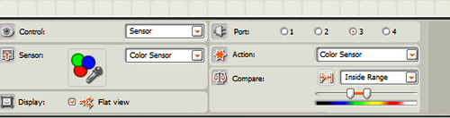
Note that you can now set the robot anywhere on the course and it 'knows' where to go.

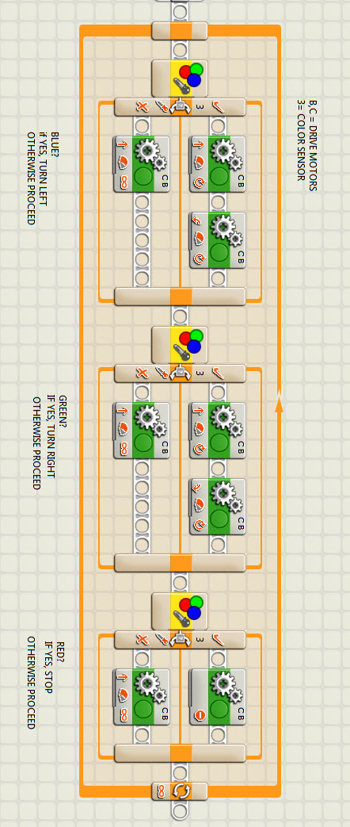
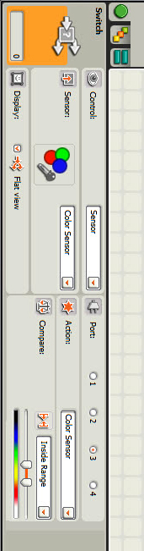
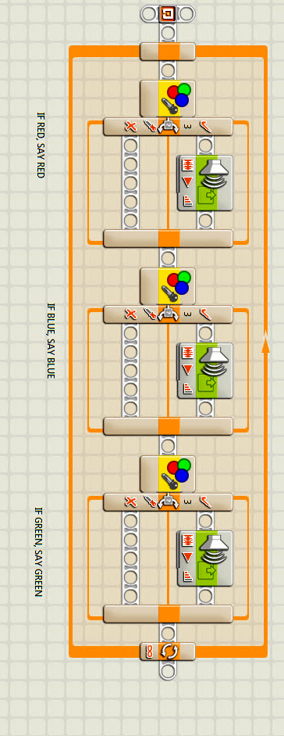
Preliminary exercise

